**Name : Radadiya Devalkumar Chandulal**

**Enrollment No. :- 200802089**

**Project ID :- 22BITPR76**

**Class :- F2**

**Name: Kakadiya Ridham Niteshbhai**

**Enrollment No. :- 200802045**

**Project ID :- 22BITPR76**

**Class :- F2**

1. Login Page :-

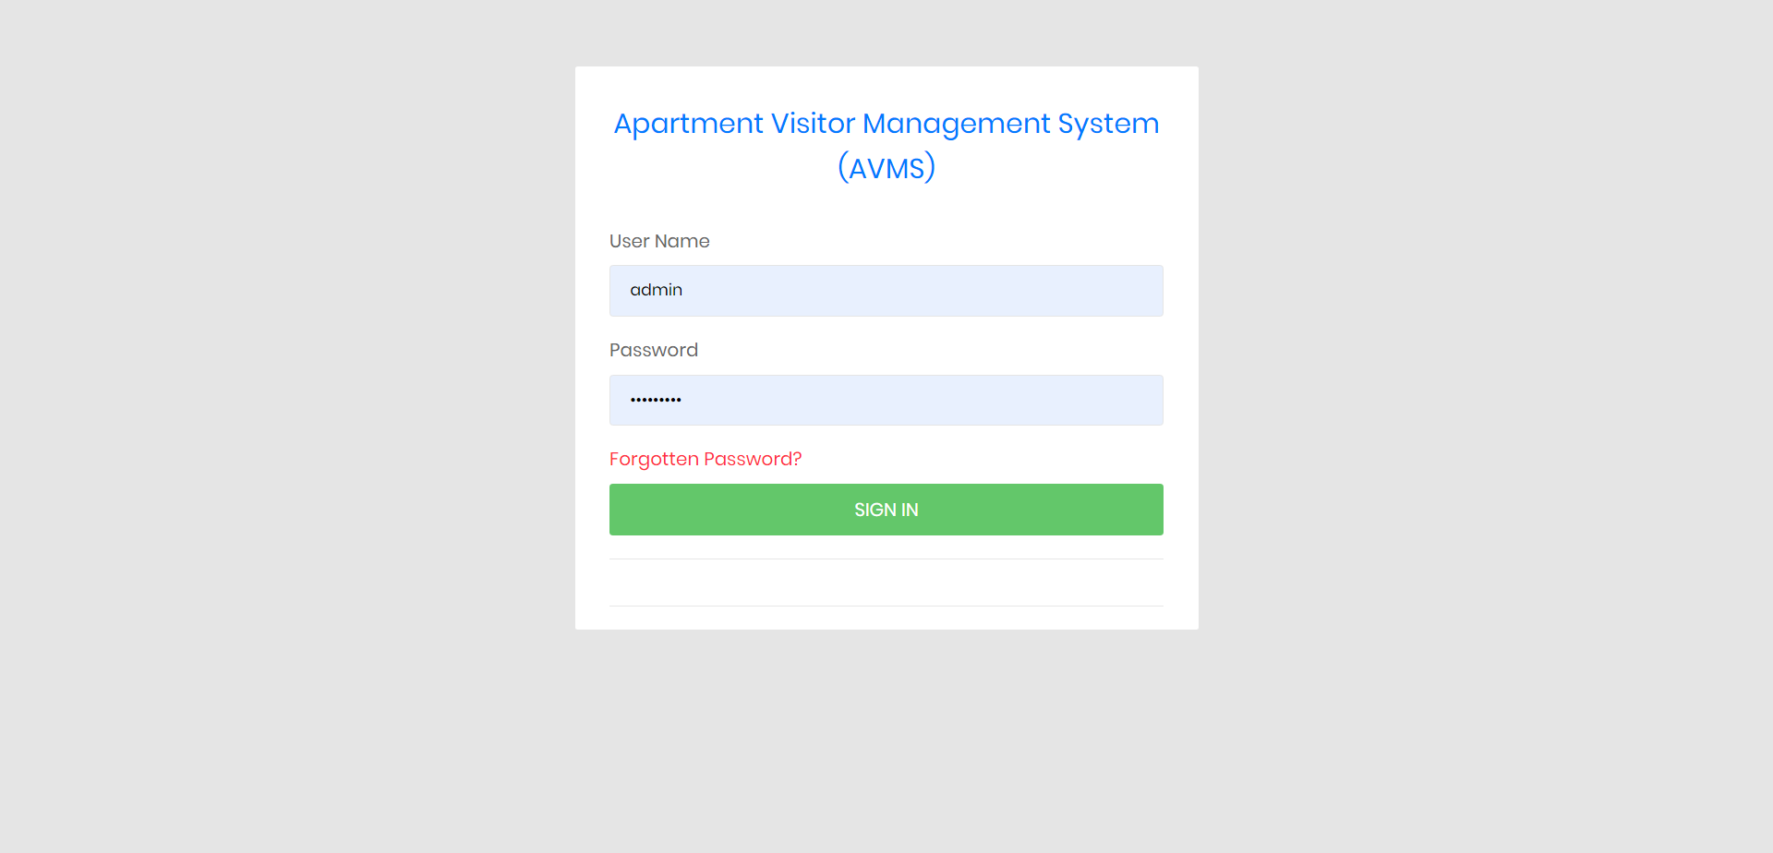

2) Dashboard :-

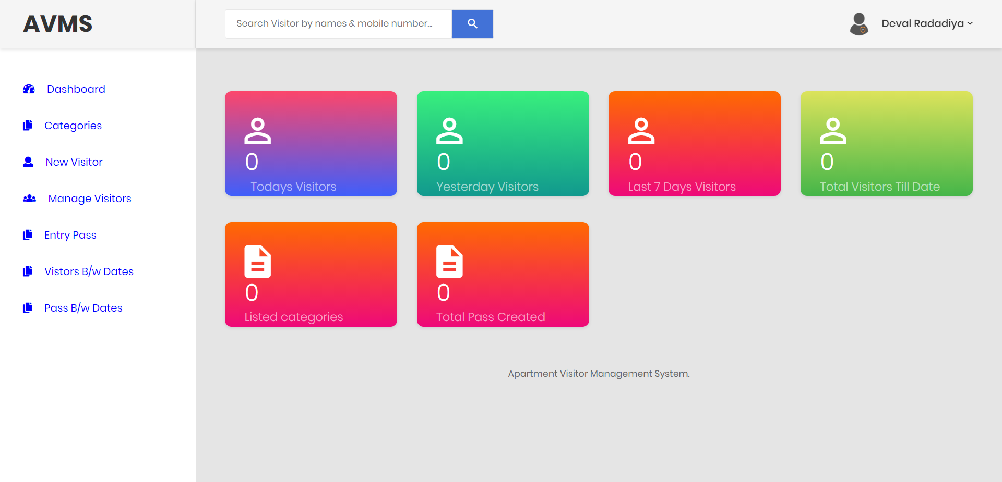

1. Add Categroies :-

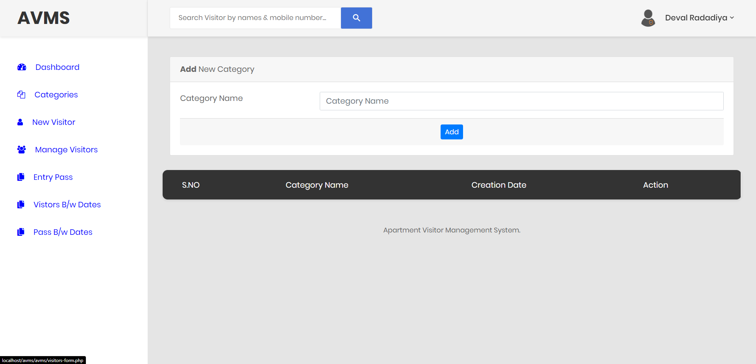

1. Add New Visitors :-

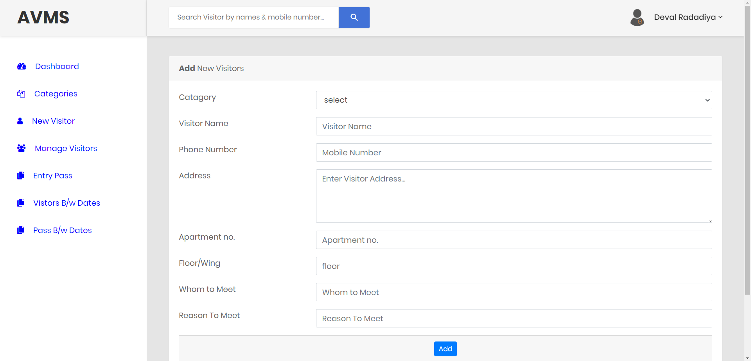

1. Manage Visitors :-

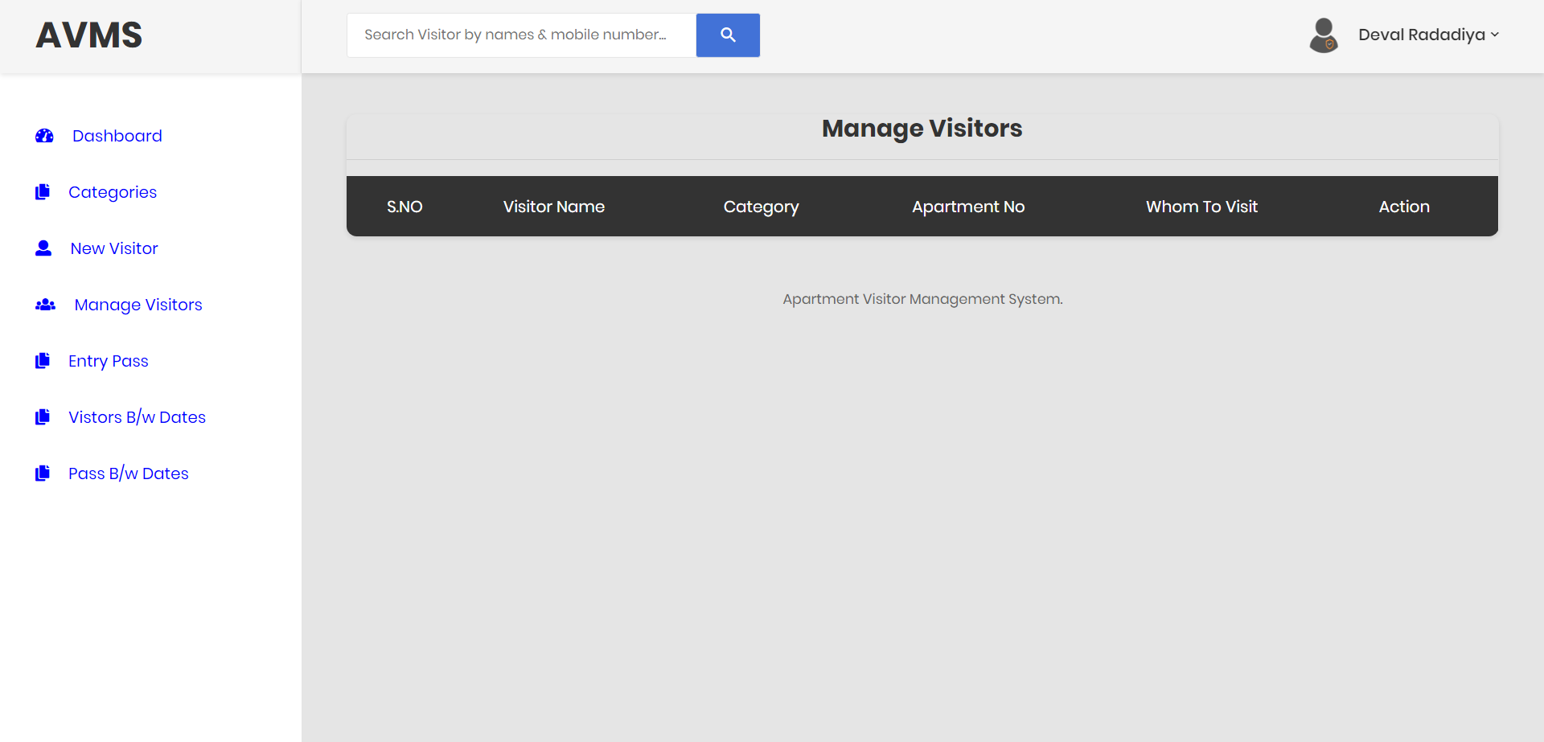

1. Manage Pass ( Create Pass ) :-

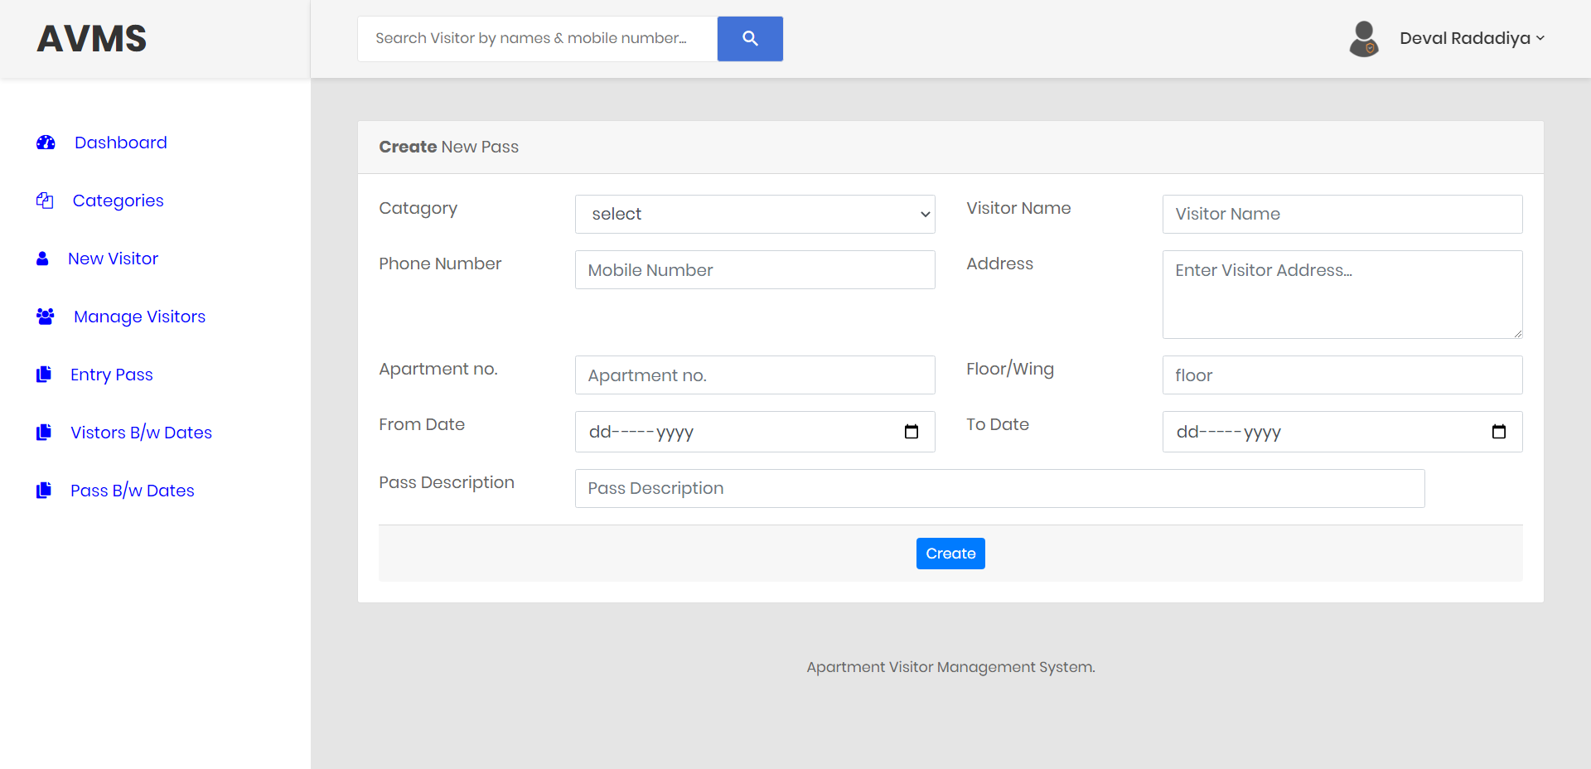

1. Manage Pass ( Manage Pass ) :-

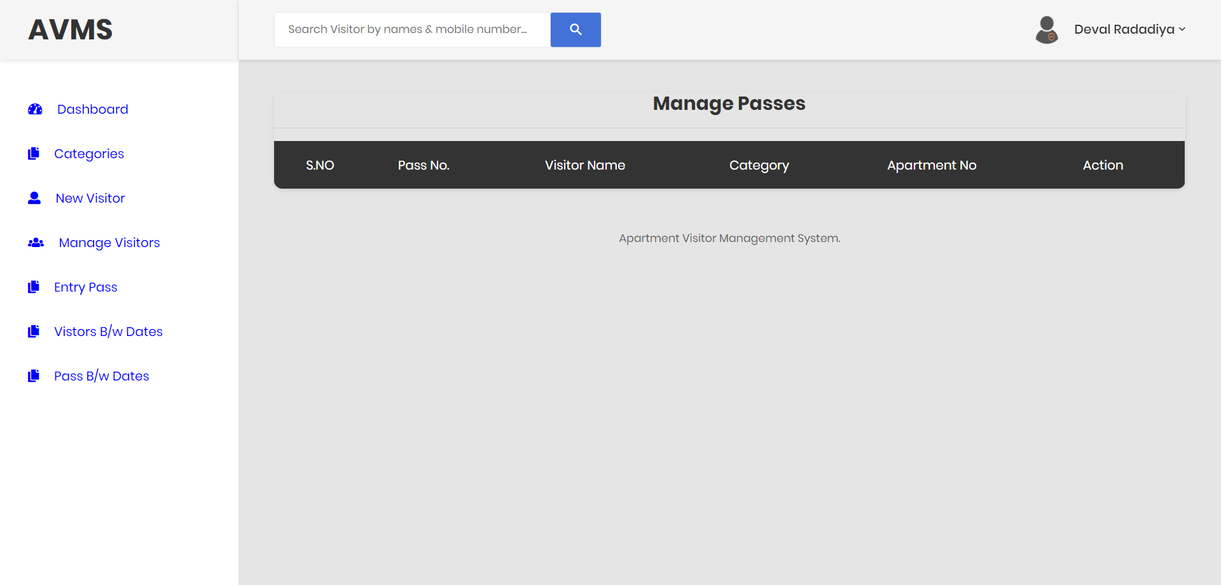

1. Visitors Between Date :-

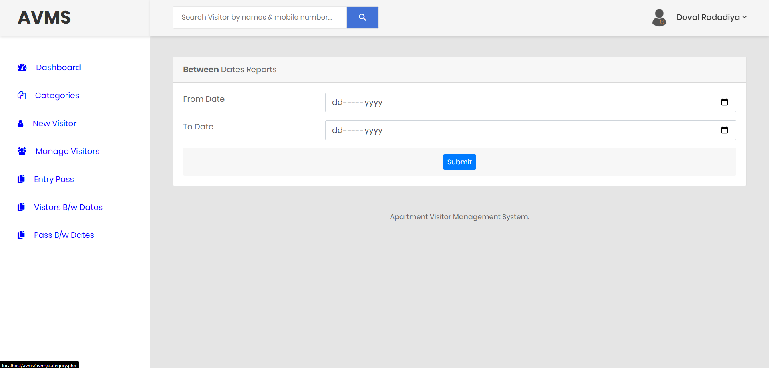

1. Pass Between Date :-

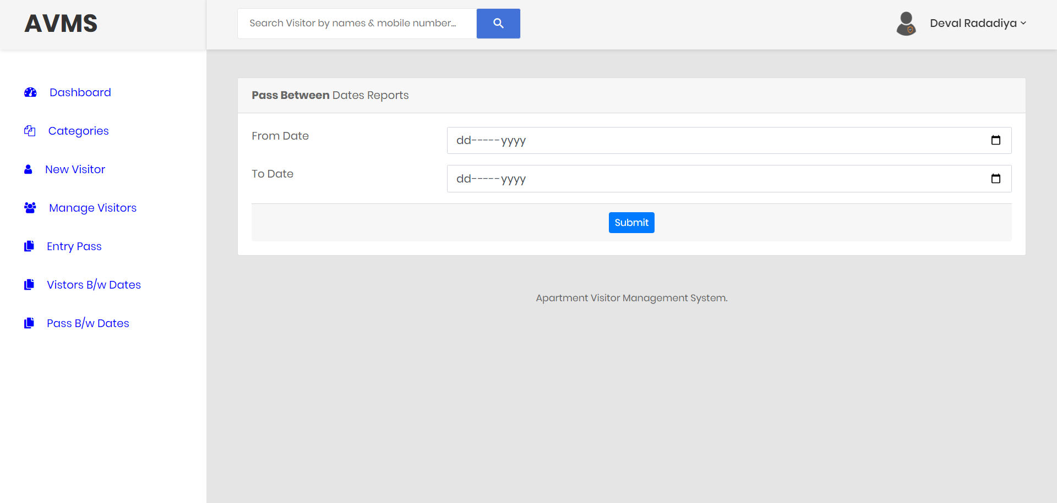

**Update Profile :-**

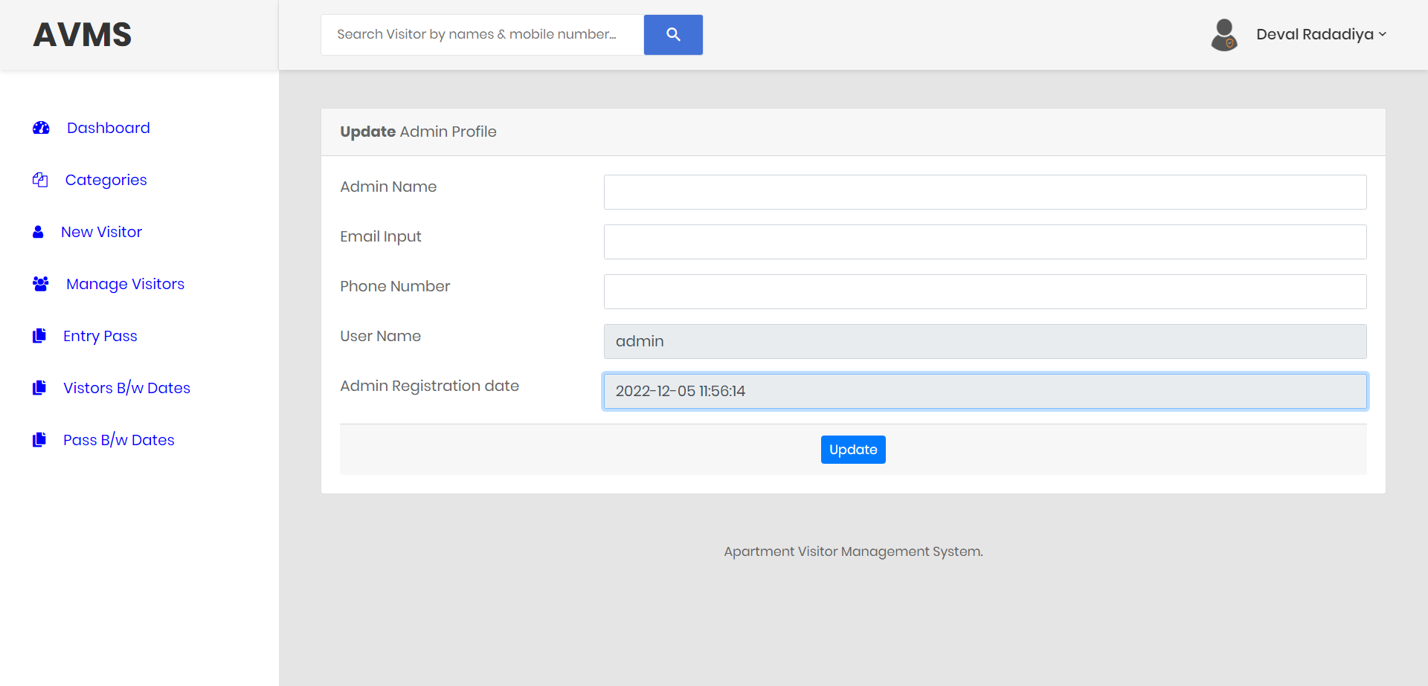

1. Change Password

